POSITION DESCRIPTION

POSITION TITLE | Board Director
HOURS OF WORK | 16 a month, flexible
TENURE | June to October 2021 (opportunity to reapply)
DATE REVIEWED | August 2021

ORGANISATIONAL CONTEXT
BPD Community was established in 2015 as a peer led, grassroots, independent not for profit.

VISION: to create a compassionate community

MISSION: to replace stigma and discrimination with hope and optimism

FOCUS:
- Information: To provide up to date, reliable, accessible information
- People: To create a community to support recovery
- Sustainability: To build programmatic and organisational sustainability, both cultural and financial
VALUES:
- Collaboration: As a community we work together, as an organisation we work with other organisations, as individuals we work with each other to achieve our mission.
- Acceptance: Both individually and collectively we practice radical acceptance as essential in all aspects of our work.
- Respect: The BPD is a diverse and varied community. We respect all peoples, their cultures and the environment.
- Empathy: Empathy leads us to compassion for others and our own self compassion. It is based on respect and compassion, it supports our collaboration.

ORGANISATIONAL STRUCTURE
The structure of the organisation is designed to encourage collaboration amongst all the volunteers of the organisation while it is in start up phase.

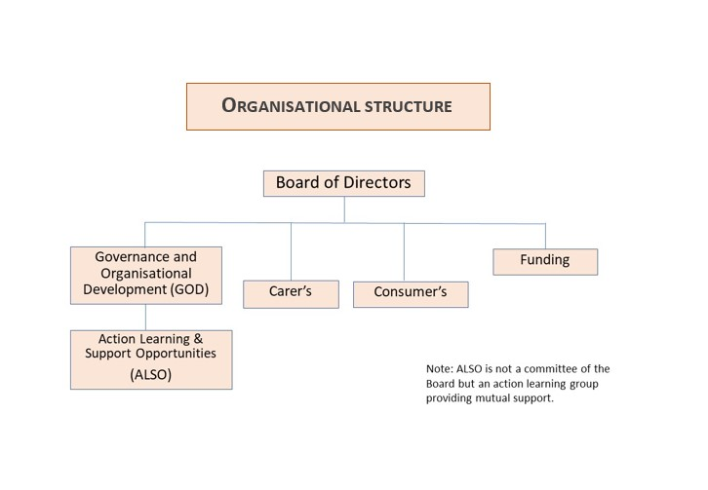

POSITION SCOPE

A Board Director is one part of a collective that makes up the Board, you share joint responsibility for the overall governance, management and strategic direction of the organisation.
Your responsibilities include ensuring the sustainability of the organisation in all aspects and strengthening the capacity of BPD Community to fulfil its mission to replace stigma and discrimination with hope and optimism. You will be required to accept responsibility for the co-ordination of one of the Board's Committees.
As an organisation in start up mode, Directors are also required to participate in operational and/or programmatic responsibilities. You will be guiding the organisation through its start up phase.

STAKEHOLDERS
Internal
Fellow Board Directors, Committee members, staff, volunteers, subscribers to BPD Community.
External
Community based mental health organisations, clinical organisations, mental health advocates, Government/private funding bodies, Philanthropic/Corporate Trusts, Corporate institutions, local community, media, regulatory bodies, contractors, suppliers.
CONFIDENTIALITY
Ensure client, staff and organisational confidentiality is maintained at all times

POSITION RESPONSIBILITIES
- Overall business performance - ensuring the organisation develops and implements strategies and supporting policies to enable it to fulfill the objectives set out in the organisation's constitution. The board delegates the day to day management of the organisation but remains accountable for the organisation's performance. The board monitors and supports management in an on-going way.
- Overall compliance performance - ensuring the organisation develops and implements systems to enable it to comply with its legal and policy obligations (complying with statutes such as the Corporations Act 2001, adhering to accounting standards) and ensure the organisation's assets are protected through appropriate risk management.

AREAS OF ACCOUNTABILITY

Culture & Leadership
Actively lead the vision, values, principles and practices of BPD Community promoting a productive, creative, collaborative and inclusive organisation culture.

Resource Management
Ensure the effective and transparent management of financial resources.
Secure and extend funding sources to meet organisational strategic objectives.
Build an efficient, accountable and motivated team committed to meeting organisational and stakeholder needs.
Ensure risk management practices are in place.
Foster a safe, healthy and environmentally sustainable workplace and public environment.
Explore and develop potential future accommodation for the organisation.

Sustainable Organisation
Ensure strategic and business planning processes stretch organisational goals and objectives.
Develop internal capability and extend external relationships and partnerships to achieve the strategic and business planning goals of the organisation.

Operations
Ensure high quality, accessible and efficient management of existing and future programs and activities.

Marketing & Sales
Deliver a marketing program that increases active participation and market share.
Ensure the efficient management of BPD Community public programs.

Governance
Inform and guide the Board to ensure the effective development of organisational strategies, plans and key initiatives.
Work effectively with the Board to ensure best practice governance, statutory compliance and risk management practices.
Ensure compliance with all BPD Community policies, practices, procedures including funding body requirements.

Other
Other duties as directed by the Board.

Salary: | The role is voluntary.

SELECTION CRITERIA
Lived experience of BPD (consumer or carer) is desirable: commitment to BPD Community’s values and strategic plan is essential.

- Tertiary qualifications and/or leadership experience in community services/not for profit sector

Demonstrates ability to efficiently and effectively govern/manage a successful organisation that meets strategic, operational and financial targets.

Demonstrates superior oral and written communication skills at all levels including influencing, networking and negotiation skills.
- Proven experience in successful financial management.
- Demonstrates ability to successfully encourage a collaborative, inclusive team, a focussed and accountable organisation.
- Experience in working with and developing strong relationships with a broad range of stakeholders including all levels of govt, community based mental health and Wellbeing organisations, clinical services, other NGO’s and research institutions.
- The ability to work safely and effectively from home.
ACKNOWLEDGEMENT
I fully understand the duties and responsibilities as outlined in this position description and will undertake to perform my role in accordance with the expectations indicated above.

Director’s Name ………………………………………………………………………………………………..

Signed…………………………………………………………………………Date………………………………..

Chairperson………………………………………………………………………Date ………………………….

