ACTION LEARNING and SUPPORT OPPORTUNITIES group
POSITION DESCRIPTION
Position title | Action Learning and Support Opportunities Group Member
Hours of work | 15 hours a month
Tenure | Two Years
Program area | To be determined
Reports to | The BPD Executive Officer
Last revised | Feb 2022

ORGANISATION: BPD Community is a peer led, grassroots, independent not for profit
VISION: To create a compassionate community
MISSION: to replace stigma and discrimination with hope and optimism
FOCUS:
- To provide up to date, reliable, evidence based, accessible information
- To create a community for people with lived experience of BPD which supports recovery
- To provide training and psychoeducation
VALUES:
Collaboration: As a community we work together, as an organisation we work with other organisations, as individuals we work with each other to achieve our mission.
Acceptance: Both individually and collectively we practice radical acceptance as essential in all aspects of our work.
Respect: The BPD is a diverse and varied community. We respect all peoples, their cultures and the environment.
Empathy: Empathy leads us to compassion for others and our own self compassion. It is based on respect and compassion, it supports our collaboration.
POSITION CONTEXT:
ALSO exists to provide an opportunity for those who wish to learn about how BPD Community operates as an organisation with a view to gaining hands on experience in the work of the organisation.
Members of the ALSO group accept responsibility for a ‘project area’ either in the operations of the organisation, program delivery or areas of governance or finance or management. ALSO members may be invited to participate in a committee of the Board that relates to their ‘project area’. An ALSO member may hold a position of responsibility within their other committee of choice, eg Co-ordinator.
The ALSO group meets monthly to provide support to its members and to share an understanding of the work of BPD Community.
The members of ALSO group report to the Board through the co-ordinators of the committee on which they serve, and the BPD Executive Officer.
POSITION SUMMARY:
Working collaboratively to meet the diverse requirements to support BPD Community’s programs as an ALSO group member. The ALSO group member is responsible to:
- Accept responsibility for specific projects with discrete time frames in an area of mutual agreement. Projects required by BPD Community are run back to back thus enabling a continuous seamless contribution from the volunteer;
- Effectively and efficiently contributing to the broader policy requirements of the other committee on which they serve.
- Working within the constraints of the organisational business plan, funded and unfunded program guidelines and organisational policies & procedures;
- Actively advocating of behalf of BPD Community and actively engaging in fundraising where possible;
- Participate in events and campaigns on major advocacy issues related to BPD with a view to create awareness in the community;
- Personal commitment to the mission, focus and values of BPD Community as well as the position statements which define our operations;
- Develop productive personal relationships with all stakeholders to achieve the goals of BPD Community.

ORGANISATIONAL CHART:
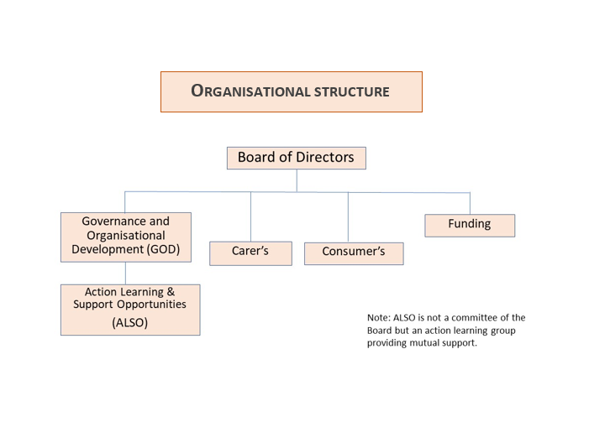

INTERNAL and EXTERNAL RELATIONSHIPS
The Member of the ALSO group is expected to contribute to the development of BPD Community whilst establishing effective communication networks and working relationships both internally and with key external stakeholders.
Reports to: | BPD Executive Officer
Supervises: | Not applicable
Internal Liaisons: | Board, Committees and Volunteers
External Liaisons: | BPD Community members, Funding bodies, Mental Health Organisations, State Authorities.
CONFIDENTIALITY:
Ensure client, staff and organisational confidentiality is maintained at all times.
ORGANISATIONAL RESPONSIBILITIES:
- Promote activities and programs in accordance with BPD Community’s Vision and Purpose statements.
- Model and promote BPD Community Values in the workplace.
- Adhere to BPD Community’s Code of Conduct, ensuring professional conduct is maintained at all times.
- Ensure Equal Opportunity principles are followed.
- Comply with all legislative requirements relevant to the position.
- Comply with policies, procedures, systems and processes of BPD Community and relevant external stakeholders.
- Follow and promote safe work practices and procedures in accordance with BPD Community Policy and legislative requirements.
- Promote awareness to the community that BPD Community encourages consumer, carer and community participation at all levels of the organization.
- Intellectual Property remains the sole property of BPD Community, unless otherwise authorized and confirmed in writing.
POSITION SPECIFIC RESPONSIBILITIES:
Program Support
- Work collaboratively with the ALSO Group and your committee of choice, including relevant internal personnel to identify policy and advocacy requirements/opportunities;
- Other duties as reasonably required in order to meet the team and organisation’s objectives.
BPD Community Advocate
- Demonstrate a knowledge of BPD, the empowerment and rights of those affected by BPD, a working knowledge of mental health terminology and the mental health care system, and how it operates;
- Contribute to the learning and sharing processes to assist in the identification of relevant policy directions and build consensus within the organisation on key issues;
- Demonstrate an understanding of legal and ethical issues and regulatory compliance;
- Demonstrate high ethical standards in trusted liaisons among people with BPD, their families and friends and those who work with them.
Project Input
Collaborate to prepare a project specific to your skills, expertise and interest that aligns with the needs of BPD Community. The outline of your project will include:
General Duties Service Promotion & Communication
- Promote, raise awareness and educate internal and external stakeholders on all aspects of your project/program to maximise partnerships, increase awareness, and provide a sense of purpose to other volunteers.
- Represent the organisation in both internal and external forums and expos.
Continuous Improvement
- Identify and actively participate in continuous improvement activities with the aim of improving BPD Community’s programs and services.
Projects
- Participate in projects/initiatives as required.
Relationships Building
- Work as a collaborative and supportive team member.
- Work as a patient advocate for BPD Community
Professional Development
- Participate in ongoing education and training programs, workshops or conferences.
KEY SELECTION CRITERIA
ESSENTIAL CRITERIA
Experience/qualifications for the role
Ability to be collaborative/cooperative
Values driven, integrity
DESIRABLE CRITERIA
Lived experience of BPD
Proven ability to contribute (hands on)
Understanding of BPD/BPD Community
Leadership ability
Ability to work independently

Key Skills, Competencies and Personal Attributes
- Demonstrated ability to consult and collaborate
- Sound time management, planning, and organisational skills to meet the demands of the busy position
- Strong interpersonal, verbal and written communication skills
- Demonstrated networking and relationship management skills
- Demonstrated capacity to work both autonomously with limited support and in a team
- Demonstrated understanding of continuous improvement, client safety and risk management principles
- Proficient in using a range of Microsoft Office packages and client/volunteer databases
Qualifications
Tertiary Qualifications in relevant field
Other requirements
- Must be a permanent Australian resident or hold a current, valid working visa.
PERFORMANCE APPRAISAL
A review shall be conducted 3 months after commencement of appointment and bi-annually thereafter.
CONDITIONS OF EMPLOYMENT
Remuneration: | The position is voluntary
Location: | There is currently no office site
Hours of duty/flexibility: | The current commitment to work is a minimum of 15 hours a month. The hours worked are flexible.
Probationary period: | There is a 3 month probationary period, during which time the volunteer must demonstrate satisfactory capability.
Pre-employment Checks: | All volunteers must be either an Australian Citizen, Permanent Resident or have an appropriate Australian visa that will legally enable them to fulfil obligations to BPD Community.
Pre-Existing Injury/Illness: | Applicants are required to disclose any condition physical or mental, which may impact on their work.
General: | Management, in consultation with you, reserves the right to modify this position description as required.  BPD Community requires relevant declarations and personal information. The collection and handling of this information will be consistent with the requirements of the Information Privacy Act 2000
Acknowledgement:
Volunteer Declaration: | I have read, understand and acknowledge the contents of this position description.
Volunteer Name:
Volunteer Signature:
Date:

