POSITION DESCRIPTION

POSITION TITLE | Fundraising Manager
LOCATION | Work from home
REPORTS TO | The Executive Officer
DATE REVIEWED | Nov 2021

ORGANISATIONAL CONTEXT
BPD Community was established in 2015 as a peer led, grassroots, independent not for profit.

VISION: to create a compassionate community

MISSION: to replace stigma and discrimination with hope and optimism

FOCUS:
- Information: To provide up to date, reliable, accessible information
- People: To create a community to support recovery
- Sustainability: To build programmatic and organisational sustainability, both cultural and financial
VALUES:
- Collaboration: As a community we work together, as an organisation we work with other organisations, as individuals we work with each other to achieve our mission.
- Acceptance: Both individually and collectively we practice radical acceptance as essential in all aspects of our work.
- Respect: The BPD is a diverse and varied community. We respect all peoples, their cultures and the environment.
- Empathy: Empathy leads us to compassion for others and our own self compassion. It is based on respect and compassion, it supports our collaboration.

ORGANISATIONAL STRUCTURE
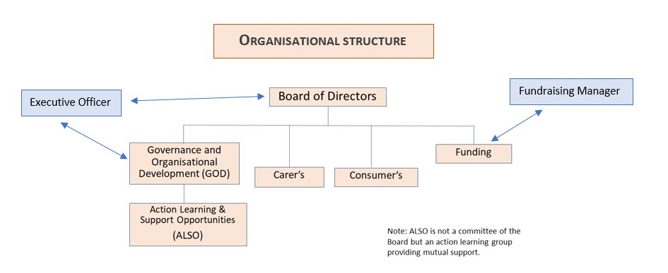

The Fundraising Manager reports to the Executive Officer.

POSITION SCOPE

The Fundraising Manager is responsible for fundraising to build an effective and sustainable organisation which supports, informs, advocates and promotes people with lived experience of BPD.

STAKEHOLDERS
Internal
Company Board, Committee members, staff, volunteers, subscribers to BPD Community.
External
Community based mental health organisations, clinical organisations, mental health advocates, Government/private funding bodies, Philanthropic/Corporate Trusts, Corporate institutions, individual donors, local community, media, regulatory bodies, contractors, suppliers.

POSITION RESPONSIBILITIES

KEY POSITION ACCOUNTABILITIES | DESCRIPTORS
Culture & Leadership  Actively lead the vision, values, principles and practices of BPD Community promoting a productive, creative, collaborative and inclusive organisation culture. | - Visible promotion of BPD Community vision, values, principles and practices to stakeholders.  - Community subscribers and all people with lived experience of BPD are treated with compassion.  - Stakeholders are treated with respect and dignity.  - Builds organisational reputation by effectively representing BPD Community at public events.  - Contribute to building a collaborative culture.
Fundraising and Resource Management  Ensure ongoing capacity funding.  Ensure ongoing programmatic funding.  Ensure the effective and transparent management of financial resources.  Secure and extend funding sources to meet organisational strategic objectives.  Build an efficient, accountable and motivated team committed to meeting organisational and stakeholder needs.  Ensure risk management practices are in place.  Foster a safe, healthy and environmentally sustainable workplace and public environment.  Explore and develop potential future accommodation for the organisation. | - Meets financial targets, especially funding circa $240,000 for FY 2021-2022  - Develop a medium to long term funding plan  - Fundraise such that adequate cash reserves are in place.  - Collaborates with stakeholders to develop pro bono contributions where appropriate and possible.  - Manages pro bono accountability of volunteers.  - Manages the donor stakeholder program  - Accounts for grant acquittals

Sustainable Organisation  Ensure strategic and business planning processes stretch organisational goals and objectives.  Develop internal capability and extend external relationships and partnerships to achieve the strategic and business planning goals of the organisation. | - Effectively supports the Board and the executive in business planning and reporting processes.  - Achieves strategic and business planning goals and outcomes.  - Champions significant business improvement initiatives.  - Actively networks resulting in enhanced profile or opportunities for BPD Community.  - Actively seeks and takes part in professional development.  - Research and develop a QA program as a source of fundraising  - Research and develop training programs as a fundraising source  - Research, identify, cultivate and secure new Corporate Partners and individual donors to grow a diverse income stream  - Manages the donor stakeholder program  - Develops and extends the non volunteer pro bono program  - Develops and Manages a VIP program
Operations  Ensure high quality, accessible and efficient management of existing and future programs and activities. | - High level of satisfaction with BPD Community experience by community members.  - Perception by stakeholders of BPD Community as a centre of excellence.  - Programs and activities are perceived by stakeholders to be of high quality, innovative, professional and well managed.
Marketing & Sales  Deliver a marketing program that increases active participation and market share.  Ensure the efficient management of BPD Community public programs. | - Develop a marketing plan for immediate implementation  - Increasing recognition of BPD Community by stakeholders.  - BPD Community’s programs are well known and regarded by external stakeholders.

Governance  Inform and guide the Board to ensure the effective development of organisational strategies, plans and key initiatives.  Work effectively with the Board to ensure best practice governance, statutory compliance and risk management practices.  Ensure compliance with all BPD Community policies, practices, procedures including funding body requirements. | - High level of satisfaction of organisational leadership and contribution by Board and internal stakeholders.  - Actively promotes best practice governance, statutory compliance and risk management practices.  - Up to date organisational policies and procedures.  - Organisational compliance with Statutory and contractual requirements, internal policies and procedures.
Other  Other duties as directed by the Chair. | - Implement the 2021-2022 Sustainability Project.

SELECTION CRITERIA
Lived experience of BPD (consumer or carer) is desirable. Commitment to BPD Community’s values and strategic plan is essential.

Essential Knowledge, Skills & Abilities

- Tertiary qualifications or experience in a related discipline with fundraising, marketing and events management well regarded;
- An ongoing commitment to professional development particularly in respect to achieving the CFRE credential; membership of FIA, AMI, or similar association well regarded;
- Proven success delivering revenue growth; demonstrated record of securing philanthropic gifts and other financial support including sponsorships, partnerships and the like;
- Experience in working with and developing strong relationships with a broad range of stakeholders including all levels of govt, community based mental health and Wellbeing organisations, clinical services, other NGO’s and research institutions.
- Proven success in influencing stakeholders in a sensitive manner; Strong networking skills;
- Proven ability to work independently and as part of a team;
- Ability to multi-task / time manage and to deliver successful outcomes on a variety of projects concurrently;
- Demonstrated competence in the use of MS Office suite, Outlook, Social media, computer and internet literacy;
- The ability to work safely and effectively from home.
Other
- Current valid driver’s license.
- Meets satisfactory Police Check.

ACKNOWLEDGEMENT
I fully understand the duties and responsibilities as outlined in this position description and will undertake to perform my role in accordance with the expectations indicated above.

Employee’s Name ………………………………………………………………………………………………..

Signed…………………………………………………………………………Date………………………………..

Chairperson………………………………………………………………………Date ………………………….

